**PA2578 – ASSIGNMENT 1**

Digital Products at Your Organization - What they Offer, Why they are needed, What Values they bring

**Digitalization**

Most parts of the organization where I work have reached the stage of digital transformation. This is also evident from the fact that they have hired me as a Data Scientist to transform parts of business, utilizing the digitized content. The telecom sector which my organization is part of has installed multiple sensors and IOT devices to collect data from multiple sources and streams. Over the years, we have been able to store and transform this data into usable format that has enabled us to develop use-cases on top that provide products capable of major transformations eg. Metrics capturing user experience coupled with data from network infrastructure has helped us develop automated AI driven solutions to Antenna Tilt that can be optimized for either user experience or availability.

To keep up with the growing need for advanced analytics and growing data from a growing number of data sources, we have developed a scalable infrastructure and development platform that enable developers and data engineers to source, manage and transform data into usable components. The infrastructure has been architectured to ensure horizontal as well as vertical scalability of processing capacity. Use of a multi-tenant architecture has made it possible to ensure fault tolerance, making the infrastructure among modern day IT systems that most multinational organizations host today.

The complementary infrastructure components developed also help us visualize massive volumes of data to generate insights and take informed decisions across multiple parts of the business eg. network performance management. The software development stack complements some of the sacable products that help provide massive efficiency gains. Eg. personalized recommendation engine for marketing campaigns. This has helped us scale multiple teams or squads that develop and maintain different software products.

Owing to the rapid spread of software products and services within the parts of the organization, we have observed network effects scale the impact of even originally thought of low value products. Eg. forecast of subscriber can not only impact sales and marketing but also planning for spectrum auction when coupled with capacity monitoring data.

However, to keep up with growing needs for business and the number of development teams, monitoring infrastructure has also scaled. Data and insights from such systems helps the leadership and strategy teams plan and optimize delivery models for efficiency and adoption. This fuels the cycle of adoption and digitalisation itself within the organization leading to massive gains in productivity and efficiency.

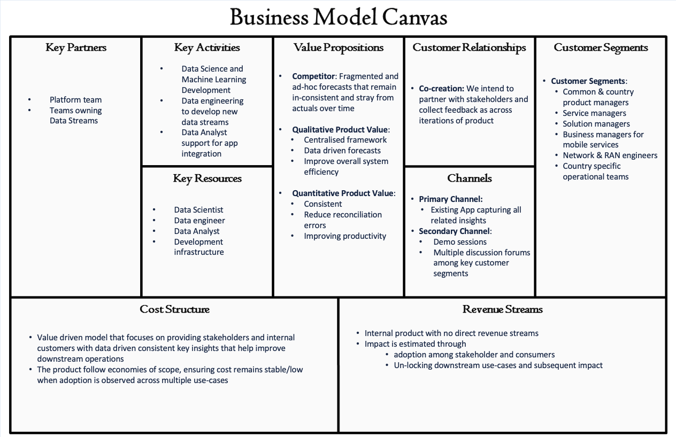

AI Traffic Forecast : **Product Strategy**

Last Modified: March 10, 2024

Author(s): @Jain, Uday

Contributors: @Jain, Uday

Project Vision:

The product is envisioned to help common & country product managers, service managers, solution managers, business managers for mobile services, network & RAN engineers as well as country specific operational teams such as sales and marketing take informed decisions to optimize operations and improve user experience through network planning, marketing and sales using accurate and reliable forecasts for data usage and user volumes.

We would develop the product in close collaboration with key stakeholders, using their business input and domain expertise to make it an integral part of decision making.

The forecasting product is intended to provide value through consistent and data driven forecasts across various levels of municipality, product type, subscription type, technology type and spectrum band. Centralization of forecasts would help improve overall system efficiency and reduce reconciliation errors thereby improving productivity.

Product Definition:

The Mobile Data Forecasts Application owned by team currently holds multiple ad-hoc forecasts and generalized insights from all countries' service usage. This application would be enhanced with AI Traffic forecast as a product that includes:

· Active subscriber forecasts

· Data usage forecasts

*Why do we need the product:*

Multiple processes require an outlook into the future, a variety of forecasts drive our ability to plan infrastructure, purchase spectrum, develop new services, strategize sales approaches, or build new products, however, today with no common strategy and central framework, most of our forecasts are done with ad-hoc methods that stray from actuals over time.

*Functional Scope of the product:*

The AI Traffic forecast product would provide accurate total data usage and subscriber count monthly forecasts for 36 months in future across multiple hierarchical levels of municipality, product type, subscription type, technology type and spectrum band.

The current scope of product excludes un-classified product categories or un-identified users (contributing to <X% of total data usage during 2023).

The forecasts would be accompanied by confidence intervals that would help the users take informed decisions in an uncertain future.

*Quality Scope of the product:*

The AI Traffic forecast product would encapsulate 2 forecasts:

1. Forecasted Total Data Usage
2. Forecasted subscriber count = Modeled Total Data Usage X Modeled Average Usage per Subscriber

Key performance metrics such as MAPE (Mean Average Percentage Error) and RMSE (Root Mean Squared Error) would be evaluated separately for both models at different underlying hierarchical levels to ensure accuracy of results. These metrics would be compared against monthly actuals to evaluate the need for model re-training. A monitoring dashboard to include model performance metrics along with input data quality metrics would ensure efficient monitoring and quality control throughout the lifecycle of the product.

MLP (Minimum Lovable Product) would include the forecasted results as a table in the database that could be enriched with data from other sources and used in the Application. e.g. To calculate capacity across different geographical zones or generate network recommendations.

Kubeflow would be used as a platform to host the model and its service. This would not only ensure established processes around MLOps could be followed when maintaining the product but also provide reliability and smooth migration when necessary.

*User experience and product:*

To improve user experience and industrialize the solution after feedback from MLP, the models would be hosted as a service that could be called in either near-real-time or at a set frequency such as monthly.

*Intended use and scope of the product:*

The product is intended to help all processes that need a future insight into data and user volumes.

The following use-cases are currently identified as high priority:

1. Calculate capacity across different geographical zones.

2. Highlight areas with mis-managed capacity utilization for sales and marketing functions as well as network operational teams.

Potential User Segments:

Potential users include common & country product managers, service managers, solution managers, business managers for mobile services, network & RAN engineers as well as country specific operational teams.

Delivery Model & Service Strategy:

The forecasts would be exposed as an internal & secured service (SaaS) and closely integrated with the target Application to provide forecasts in a pre-defined format.

MLOps would ensure any updates to the existing model or model refresh cycles would not impact the user experience.

Performance monitoring dashboard would be used to track quality of both input and output data to plan re-training sprints.

Data Sourcing Strategy:

The product would be developed using data sourced from data lake. All external data sources would be first ingested into the data lake before using them in the model. This would ensure a standardized quality control and close integration with existing processes and services within the organization.

Product Development Strategy:

The product would be developed using open-source algorithms and services or custom developed components on internal infrastructure maintained by Platform Team to reduce dependencies and cost on external providers as well as maintain high levels of data privacy and compliance.

The product would be developed for each X country and gradually scoped for other countries depending on the feedback, adoption, and prioritization with relevant stakeholders.

Partnerships and Collaboration:

The product development and maintenance cycle would mean close collaboration with the Platform team to develop required infrastructure for industrialization and hosting underlying models.

The product performance would depend on the quality of underlying data and consequently, collaborations with teams owning and collating the required data streams would be key to the success of the product.

**Values**

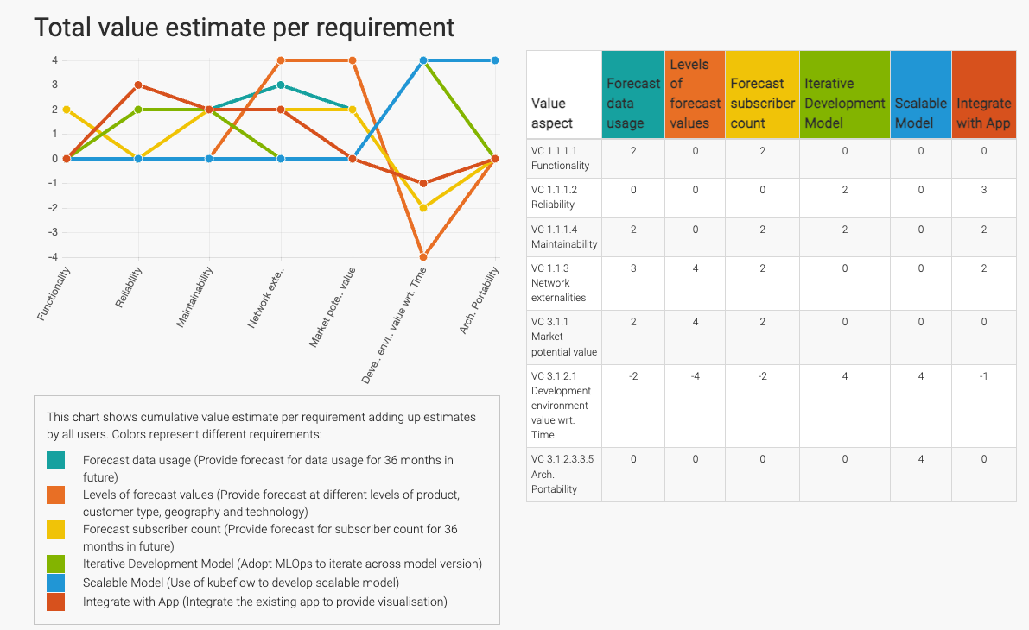

**Reflection**: During this release we have made significant positive impact to Network externalities, Market potential value and Maintainability of the product at the cost of Development environment value wrt. Time. Other attributes such as Functionality, Reliability and Arch. Portability would also be improved and provide long term benefit to the product life cycle.